# Advertising message type

|  |  |
| --- | --- |
| 0x29 | PB-ADV |
| 0x2A | Mesh Message |
| 0x2B | Mesh Beacon |

# Advertising bearer PDU

|  |  |  |
| --- | --- | --- |
| Length | AD Type | Contents |
| 0xXX | <<Mesh Message>> | Network PDU |
| 0xXX | <<PB-ADV>> | PB-ADV PDU |
| 0xXX | <<Mesh Beacon>> | Beacon PDU |

# Beacon PDU

|  |  |
| --- | --- |
| Beacon Type | Beacon Data |

# PB-ADV PDU

|  |  |  |
| --- | --- | --- |
| Link ID | Transaction Number | Generic Provisioning PDU |

|  |  |  |
| --- | --- | --- |
| Field | Size(octets) | Description |
| Link ID | 4 | The identifier of a link |
| Transaction Number | 1 | The number for identifying a transaction |
| Generic Provisioning PDU | 1-24 | Generic Provisioning PDU being transferred |

## Generic Provisioning PDU

|  |  |
| --- | --- |
| Generic Provisioning Control | Generic Provisioning Payload |

|  |  |  |
| --- | --- | --- |
| Field | Size(octets) | Description |
| Generic Provisioning Control | 1-17 | Generic Provisioning Control field |
| Generic Provisioning Payload | 0-64 | Generic Provisioning Payload(segments of the provisioning PDU) |

The two least significant bits of the first octet of the Generic Provisioning Control field contain a Generic Provisioning Control Format (GPCF) field that determines the format of the Generic Provisioning Control field.

|  |  |
| --- | --- |
| Value | Description |
| 0b00 | Transaction Start |
| 0b01 | Transaction Acknowledgment |
| 0b10 | Transaction Continuation |
| 0b11 | Provisioning Bearer Control |

### Transition Start PDU

|  |  |  |  |  |  |
| --- | --- | --- | --- | --- | --- |
| SegN | 0 | 0 | Total Length | FCS | Data(at minimum 1 octet) |

|  |  |  |
| --- | --- | --- |
| Field | Size(bits) | Description |
| SegN | 6 | The last segment number |
| GPCF | 2 | 0b00 = Transaction Start |
| TotalLength | 16 | The number of octets in the Provisioning PDU |
| FCS | 8 | Frame Check Sequence of the Provisioning PDU |

### Transition Acknowledgment PDU

|  |  |  |
| --- | --- | --- |
| Padding | 0 | 1 |

|  |  |  |
| --- | --- | --- |
| Field | Size(bits) | Description |
| Padding | 6 | 0b000000; all other values Prohibited |
| GPCF | 2 | 0b01 = Transaction Acknowledgment |

### Transaction Continuation PDU

|  |  |  |  |
| --- | --- | --- | --- |
| Segment Index | 1 | 0 | Data(at minimum 1 octet) |

|  |  |  |
| --- | --- | --- |
| Field | Size(bits) | Description |
| SegmentIndex | 6 | Segment number of the transaction |
| GPCF | 2 | 0b10 = Transaction Continuation |

### Provisioning Bearer Control

|  |  |  |  |
| --- | --- | --- | --- |
| Bearer Opcode | 1 | 1 | Parameters |

|  |  |  |
| --- | --- | --- |
| Field | Size(bits) | Description |
| BearerOpcode | 6 | The opcode for the provisioning bearer control PDUs |
| GPCF | 2 | 0b11 = Provisioning Bearer Control |
| Parameters | Variable | Parameters defined by each BearerOpcode |

BearerOpcode

|  |  |  |
| --- | --- | --- |
| Value | Message | Notes |
| 0x00 | Link Open | Open a session on a bearer with a device |
| 0x01 | Link ACK | Acknowledge a session on a bearer |
| 0x02 | Link Close | Close a session on a bearer |
| 0x03-0x3F | RFU | Reserved for Future Use |

# Network PDU

|  |  |  |  |  |  |  |  |  |
| --- | --- | --- | --- | --- | --- | --- | --- | --- |
| IVI | NID | CTL | TTL | SEQ | SRC | DST | Transport PDU | NetMIC |
|  |  | Obfuscated | | | | Encrypted | |  |

|  |  |  |
| --- | --- | --- |
| Field Name | Bits | Notes |
| IVI | 1 | Least significant bit of IV Index |
| NID | 7 | Value derived from the NetKey used to identify the  Encryption Key and Privacy Key used to secure  this PDU |
| CTL | 1 | Network Control |
| TTL | 7 | Time To Live |
| SEQ | 24 | Sequence Number |
| SRC | 16 | Source Address |
| DST | 16 | Destination Address |
| TransportPDU | 8 to 128 | Transport Protocol Data Unit |
| NetMIC | 32 or 64 | Message Integrity Check for Network |

|  |  |  |
| --- | --- | --- |
| CTL Field | Message Type | NetMIC Size(bits) |
| 0 | Access Message | 32 |
| 1 | Control Message | 64 |

|  |  |  |  |
| --- | --- | --- | --- |
| Network PDU | | | 依次向下发送，可通过index区分interface |
| Network Interface1 | Network Interface2 | Network Interface3 |
| Advertising Bearer | GATT Bearer | Local Bearer |

# Lower Transport PDU

|  |  |  |
| --- | --- | --- |
| CTL Filed | SEG Field | Lower Transport PDU Format |
| 0 | 0 | Usegmented Access Message |
| 0 | 1 | Segmented Access Message |
| 1 | 0 | Unsegmented Control Message |
| 1 | 1 | Segmented Control Message |

## Unsegmented Access Message

|  |  |  |  |
| --- | --- | --- | --- |
| SEG(0) | AKF | AID | Upper Transport Access PDU |

|  |  |  |
| --- | --- | --- |
| Field | Size(bits) | Notes |
| SEG | 1 | 0 = Unsegmented Message |
| AKF | 1 | Application Key Flag |
| AID | 6 | Application key identifier |
| Upper Tranport Access PDU | 40 to 120 | The Upper Transport Access PDU |

AKF为1表示access的pdu是用application key加密的，为0表示是用device key加密的。

## Segmented Access Message

|  |  |  |  |  |  |  |  |
| --- | --- | --- | --- | --- | --- | --- | --- |
| SEG(1) | AKF | AID | SZMIC | SeqZero | SegO | SegN | Segment m |

|  |  |  |
| --- | --- | --- |
| Field | Size(bits) | Notes |
| SEG | 1 | 1 = Segmented Message |
| AKF | 1 | Application Key Flag |
| AID | 6 | Application key identifier |
| SZMIC | 1 | Size of TransMIC |
| SeqZero | 13 | Least signidicant bits of SeqAuth |
| SegO | 5 | Segment Offset number |
| SegN | 5 | Last Segment number |
| Segment m | 8 to 96 | Segment m of the Upper Transport Access PDU |

## Unsegmented Control Message

|  |  |  |
| --- | --- | --- |
| SEG(0) | Opcode | Parameters |

|  |  |  |
| --- | --- | --- |
| Field | Size(bits) | Notes |
| SEG | 1 | 0 = Unsegmented Message |
| Opcode | 7 | 0x00 = Segment Acknowledge  0x01 to 0x7F = Opcode of the Transport Control message |
| Parameters | 0 to 88 | Parameters for the Transport Control message |

## Segment Acknowledgment Message

|  |  |  |  |  |  |
| --- | --- | --- | --- | --- | --- |
| SEG(0) | Opcode(0x00) | OBO | SeqZero | RFU | BlockAck |

|  |  |  |
| --- | --- | --- |
| Field | Size(bits) | Notes |
| SEG | 1 | 0 = Unsegmented Message |
| Opcode | 7 | 0x00 = Segment Acknowledgment Message |
| OBO | 1 | Friend on befalf of a Low Power node |
| SeqZero | 13 | SeqZero of the Upper Transport PDU |
| RFU | 2 | Reserved for Future Use |
| BlockAck | 32 | Block acknowledgment for segments |

## Segmented Control Message

|  |  |  |  |  |  |  |
| --- | --- | --- | --- | --- | --- | --- |
| 1 | Opcode | RFU | SeqZero | SegO | SegN | Segment m |

|  |  |  |
| --- | --- | --- |
| Field | Size(bits) | Notes |
| SEG | 1 | 1 = Segmented Message |
| Opcode | 7 | 0x00 = Reserved  0x01 to 0x7F = Opcode of the Transport Control message |
| RFU | 1 | Reserved for Future Use |
| SeqZero | 13 | Least significant bits of SeqAuth |
| SegO | 5 | Segment Offset number |
| SegN | 5 | Last Segment number |
| Segment m | 8 to 64 | Segment m of the Upper Transport Control PDU |

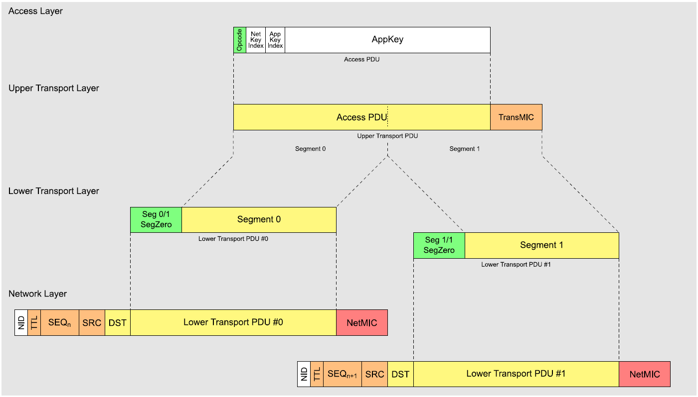

# Upper Transport Layer

## Upper Transport Access PDU

|  |  |
| --- | --- |
| Encrypted Access Payload | Transport MIC(TransMIC) |

|  |  |  |
| --- | --- | --- |
| Field Name | Octets | Notes |
| Encrypted Access Payload | 1 to 380 | The encrypted access payload |
| TransMIC | 4 or 8 | The message integrity check value for the access payload |

## Upper Transport Control PDU

|  |  |
| --- | --- |
| Number of Packets | Transport Control PDU Payload Size |
| 1 | 11(Unsegmented) |
| 1 | 8(Segmented) |
| 2 | 16 |
| 3 | 24 |
| N | n*8 |
| 32 | 256 |